Developer Client Feedback

This document is about the client and developer interaction with Ben (client) and the developer (William: me), this document states all the changes that, were changed or removed to be able to acceptable client and suit user experience.

Contents

Change 01: User Types 2

Client Approach 2

Developer Approach 2

Change 02: Map as Home Page 3

Client Approach 3

Developer Approach 3

Change 03: Unable to implement due to short timeframe 4

Client Approach 4

Developer Approach 4

Select the and state the chosen option below:

Change 01: Developer approach selected

Change 02: Developer approach selected

Change 03: Developer approach selected

I as the Client accept all changes and have been discussed by the developers that these changes had to be made to satisfy user experience and overall functionality of the website.

I also understand that changes cannot be made unless the developer is able to make changes and discuss the situation when a change/problem occurs.

Sign here:

Client Signature: X_______________________________________­­­­__________

## Change 01: User Types

### Client Approach

The requirements from the client was to have different users types, where the user can login by selecting the user type “Student, Tourist or Business” by a dropdown box, a mock-up shown below

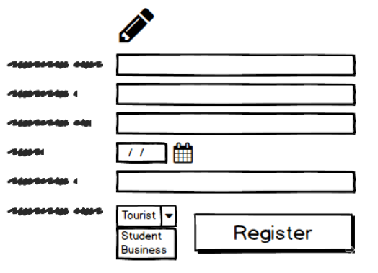

Idea was acceptable, however the issue was when the requirements also suggested that users can also view other user type features where other users could not. This was difficult to understand at first, however after several meetings, we were able to come to not only a conclusion but also another approach.

### Developer Approach

As the client wishes to view other features, the best idea was to follow the second requirement, as a user types features was considered to be only about what users searched for. Shown below are how the users are different from each other. The difference was what each user type is looking for:

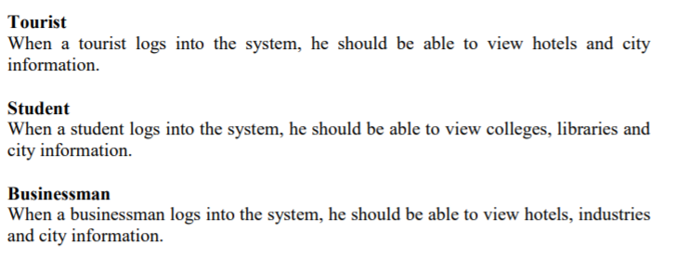

The developer solution was simply allow users to login as one user type and then when logged in be able to filter the database according to three options in the navigation bar which was “Student, Tourist and Business”. So, for example if “Student” was selected it would filter the database results to “Colleges” and “libraries” and click to views information on them.



 🡨 here is the url which filters the database according to student. If the spot information has college, library or entertainment as its category then when clicking “Student” button will show this spot information. The same goes for the tourist and business.

Tourist:



Business:



## Change 02: Map as Home Page

### Client Approach

One of the requirements from the client was the homepage, where the client had the home page, which was not a great idea, as if a user wanted to find a place of interest, the user wants to know all the places the website has to offer. Such as “New”, “Popular” or “Featured” and even the very places themselves such as places/buildings/interests, rather than leading to a page that simply has a map, this might as well go to google maps instead

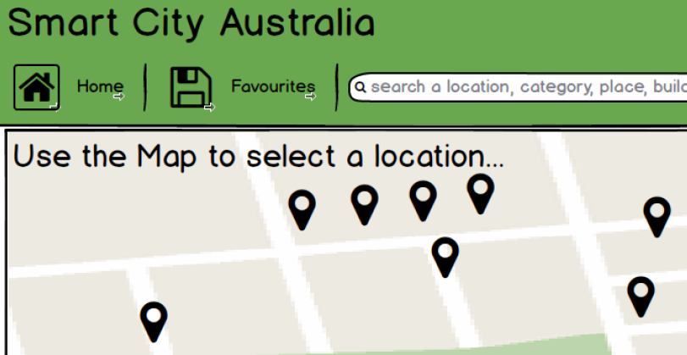

### Developer Approach

Give the user as soon as he/she logs in a list of places as the home page than making one look for one. This allows a user to view all places that the website has to offer and also favourite them at any time, which is then automatically added to her favourites which she can view at any time (favourites was already a feature since the beginning). Below is what me (William) as the developer had in mind.

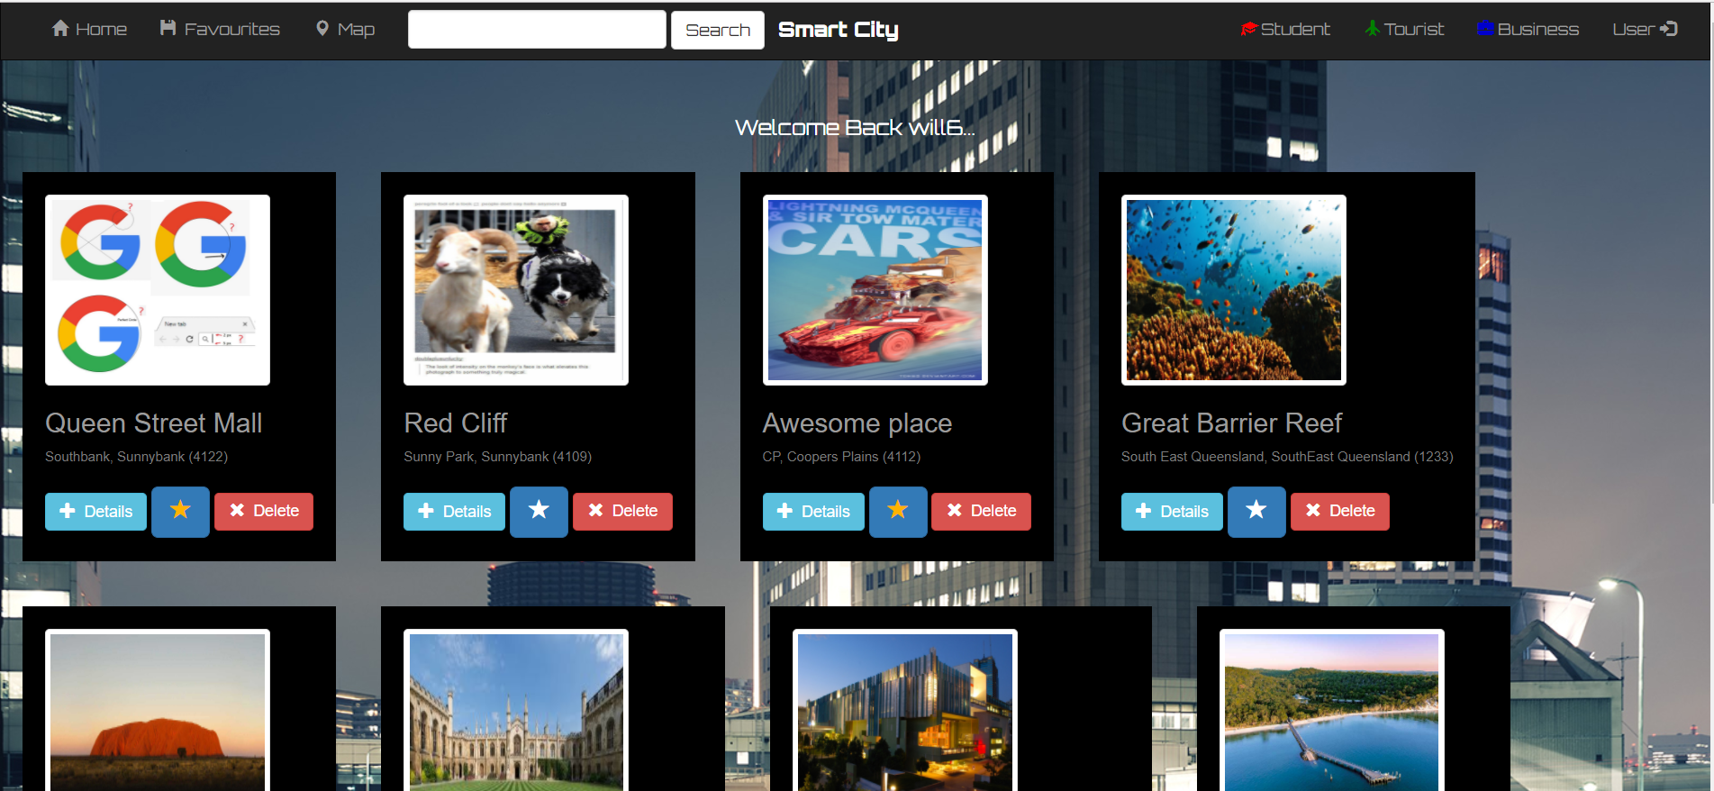

## Change 03: Unable to implement due to short timeframe

### Client Approach

1. The client wanted a language option, especially for tourists that might come from different worlds, as there might be a chance that a majority may not even speak English but their own language, this option however was decided to be implemented last, however due to the time constraint it was not able to be implemented.
2. Settings/Account: this was viewing the users profile and able to change his/her settings at any time in the options menu in the navigation page.
3. Social Media: logging in via social media was a great idea to retrieve information rather than the user to add his/her information manually.

### Developer Approach

1. Unable to complete language feature
2. Users were able to login, log-out and register, but was unable to login to view users profile and change settings etc.
3. Unable to complete Social media login

Most issues happened because of the short timeframe and meeting the client’s deadline on time, however the client was co-operative and was happy with the website overall and was very impressed.